MUNER – MOTORVEHICLE UNIVERSITY OF EMILIA ROMAGNA  
  
ADVANCED AUTOMOTIVE ELECTRONIC ENGINEERING  
COMPLIANCE DESIGN OF AUTOMOTIVE SYSTEMS

PROJECT REPORT

Design of a model-based Linear Quadratic Regulator for a DC motor

Angelo D’Aloia  
Filippo Serafini

Academic Year 2018/2019

Contents

1. Contents 2
2. 1. Introduction 3
3. 2. DC Motor Modelling 3
4. 2.1 System description and equations 3
5. 2.2 State Space Representation 3
6. 2.3 Simulink model 3
7. 3. Linear Quadratic Regulator 3
8. 3.1 Control description and equations 3
9. 3.2 Reference Tracking: LQI 3
10. 3.3 Simulink model 4
11. 3.4 Tuning & Performance 4
12. 4. Hardware Implementation 4
13. 4.1 System description 4
14. 4.2 Simulink Model 4
15. 4.3 Code Generation 4
16. Introduction

The following project is an implementative pursuance of the project from colleagues A. Russo and E. Galletti who designed and trained a neural network capable of estimating the parameters of a DC motor.

Therefore, the aim of this project is to exploit these parameters to control the DC motor by means of a Linear Quadratic Regulator with reference tracking. The proposed development environment is MATLAB that will offer a versatile and powerful platform to design and test the control. Finally thanks to MATLAB’s code generation capabilities both estimation and control codes will be deployed on a demoboard in order to test it on a Hardware In the Loop facility.

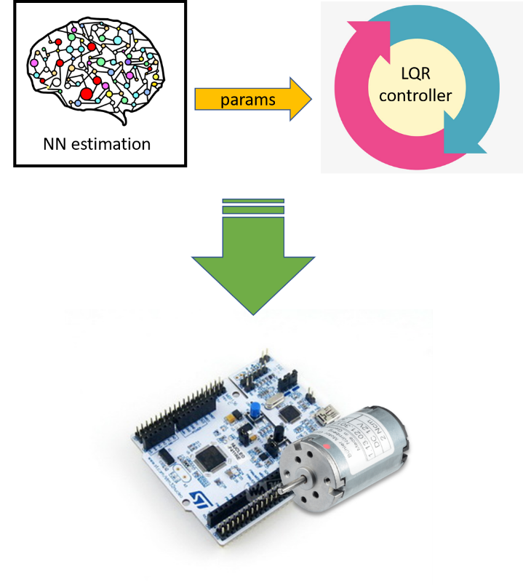

Figure - General scheme of the project

1. DC Motor Modelling

A DC motor is any of a class of rotary electrical machines that converts direct current electrical energy into mechanical energy. The most common types rely on the forces produced by magnetic fields. Nearly all types of DC motors have some internal mechanism, either electromechanical or electronic, to periodically change the direction of current flow in part of the motor.

The behaviour of a DC motor can be easily modelled by means of the following scheme:

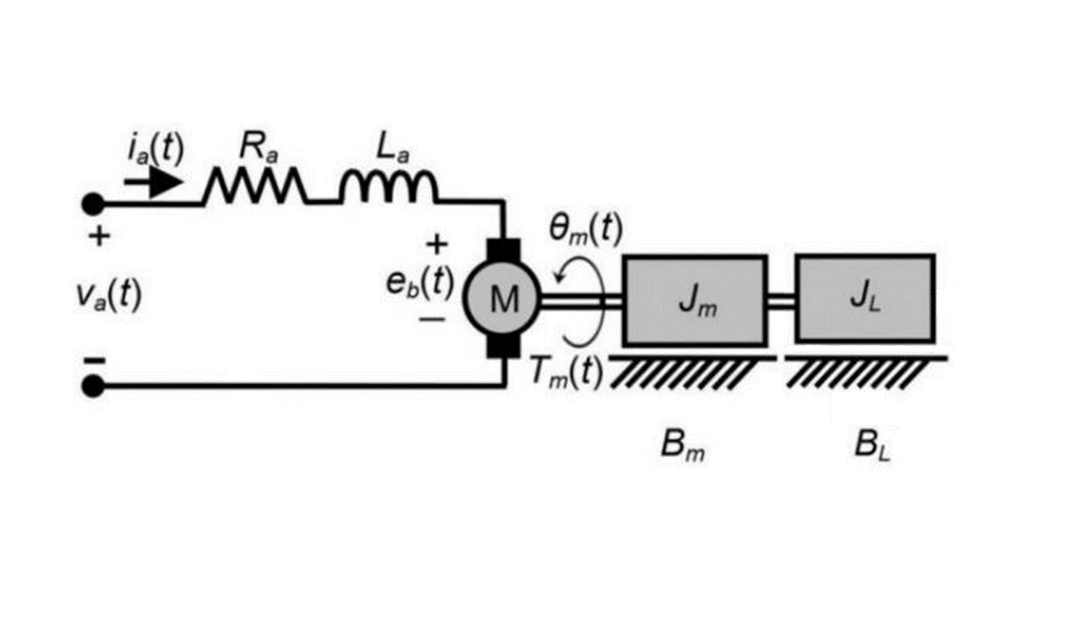

Figure - DC motor model

As one can see in Fig. 2, the motor has an electromechanical scheme which is governed, in its simplest model, by two linear equations. The first is the electrical mesh on the motor’s voltages

$$L_{a}\dot{i_{a}}(t)+R_{a}i_{a}\left(t\right)+ K_{b}ω_{m}\left(t\right)=v_{a}\left(t\right) (1)$$

While the second is a balance between the motor inertia and the torque generated by the electric energy conversion:

$$\dot{ω_{m}}\left(t\right){(J}_{m}+J_{L})+B_{m}ω_{m}\left(t\right)= K_{b}i_{a}(t) (2)$$

Where $K_{b}$ is the *back electromotive coefficient* and $B_{m}$ is the *viscous damping coefficient* of the motor’s shaft.

* 1. State Space Representation

Thanks to linearity of the system, its State Space Representation is quite straightforward and it is given by:

With

* 1. Simulink model

1. Linear Quadratic Regulator

3.1 Control description and equations

3.2 Reference Tracking: LQI

1. 3. Simulink model
   4. Tuning & Performance
2. Hardware Implementation

4.1 System description

4.2 Simulink Model

4.3 Code Generation